

Sky Smart Technology (Pvt) Ltd

Sustainability Web Application

**Activity Diagrams**

**for**

**Health and Safety Module**

**Version 1.0**

**Date : 05/03/2025**

Table of Contents

**1.**  **Accident Management** 3

**2.** **Incident Management** 4

**3.** **Report a New Hazard Risk** 5

**4.** **Document Management** 6

**5.** **Occupational Health** 7

**5.1 Occupational Health – Clinical suite** 7

**5.2 Occupational Health – Medicine Inventory** 8

**5.3 Occupational Health-Purchase Inventory** 9

**5.4 Occupational Health – Maternity Register** 10

# **Accident Management**

# **Incident Management**

# **Report a New Hazard Risk**

# **Document Management**

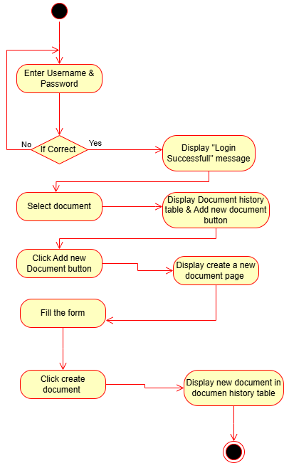

# **Occupational Health**

## **5.1 Occupational Health – Clinical suite**

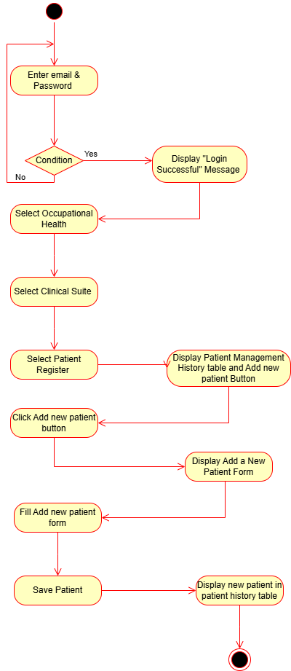

## **5.2 Occupational Health – Medicine Inventory**

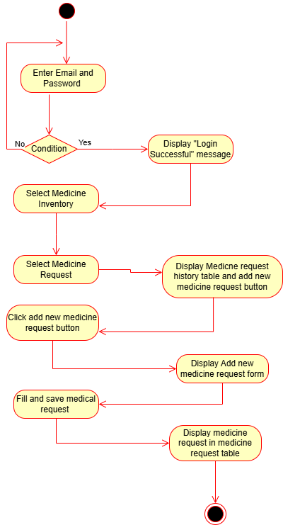

## **5.3 Occupational Health-Purchase Inventory**

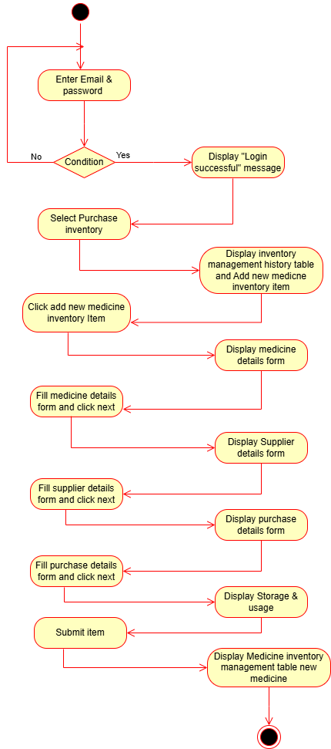

## **5.4 Occupational Health – Maternity Register**

